Fall 2026
Large Instrumental Ensemble Auditions

CLARINET
Monday, August 24, 2026
3:00-4:30 p.m. Westbrook Music Building Room 207

Arrive before 3:00 p.m. and be prepared to play (instrument together and warmed up). You will choose an audition number from a GTA upon arrival. Please do not gather outside the studio door during the auditions as the door is not soundproof.
Please indicate your ensemble preference on your audition form.
You may be considered to play an auxiliary clarinet in one of the ensembles.

Please fill out the form below and bring to your audition
PLEASE WRITE LEGIBLY
UNL Large Instrumental Ensemble Audition Form

Name: _______________________________________________________________________
Phone: _______________________________ Email: ________________________________
State any known class conflicts with Symphony Orchestra (MWF 1:30-2:50) or Wind Ensemble (MWF 3:30-4:50) and your ensemble preference:
______________________________________________________________________________
______________________________________________________________________________
Auxiliary instrument preference and/or experience (select at least one answer):
___ E-flat clarinet ___ Bass clarinet ___ Alto clarinet ___ Contrabass clarinet
___ No auxiliary experience but can’t wait to try if needed

1) Dmitri Shostakovich, Festive Overture, Op. 96
Band transcription by Donald Hunsberger

Half note = 144-152 (take it slower if needed)
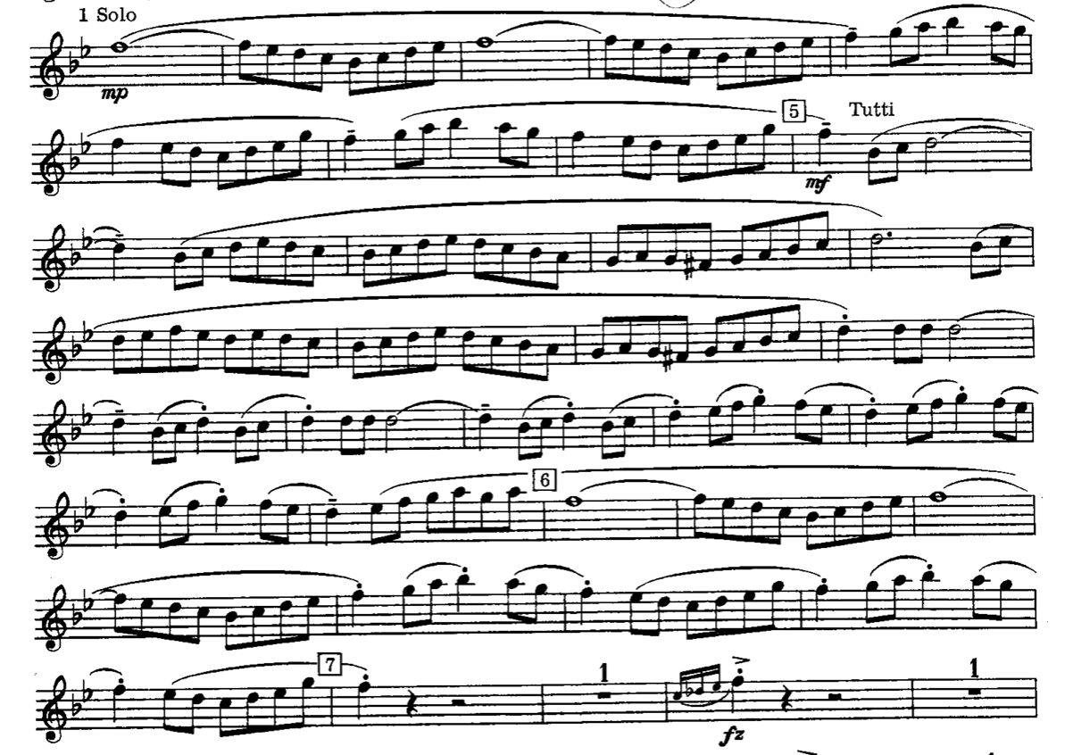

2) Maurice Ravel, Bolero

Quarter note = c. 72
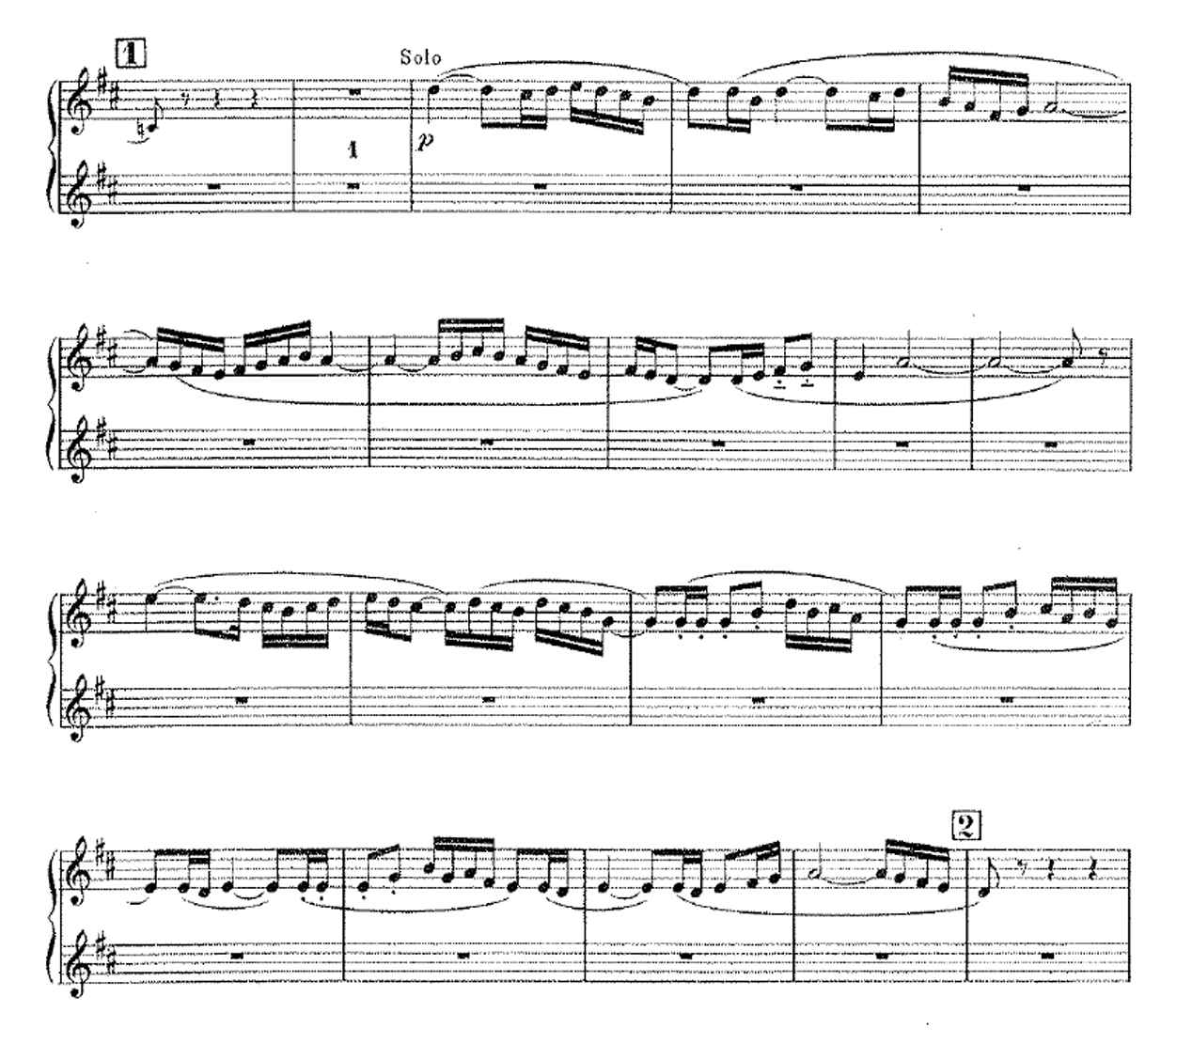

3) Felix Mendelssohn, Symphony No. 3, Op. 56 (“Scottish”)

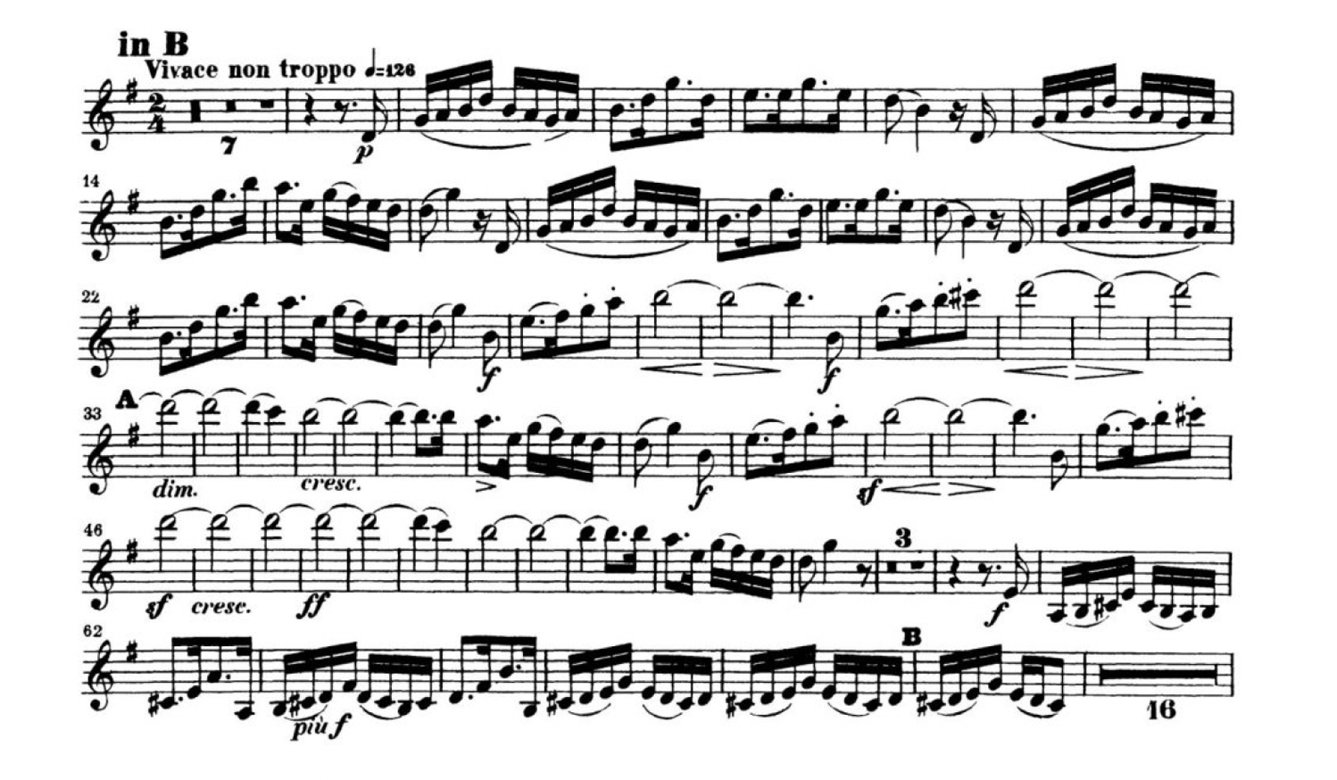

4) Ingolf Dahl, Sinfonietta

