Fall 2026
Large Instrumental Ensemble Auditions

EUPHONIUM & TUBA
Date TBD
Time TBD, Westbrook Music Building Room 220

Arrive early and be prepared to play (instrument together and warmed up). Please do not gather outside the studio door during the auditions as the door is not soundproof.
Please indicate your ensemble preference on your audition form.

Please fill out the form below and bring to your audition
PLEASE WRITE LEGIBLY
UNL Large Instrumental Ensemble Audition Form

Name: _______________________________________________________________________
Phone: _______________________________ Email: ________________________________
State any known class conflicts with Symphony Orchestra (MWF 1:30-2:50) or Wind Ensemble (MWF 3:30-4:50) and your ensemble preference:
______________________________________________________________________________
______________________________________________________________________________
Auditioning on: Euphonium ___ (Wind Ensemble only) Tuba ___

Euphonium – Kopprasch, 60 Selected Studies (No. 48)

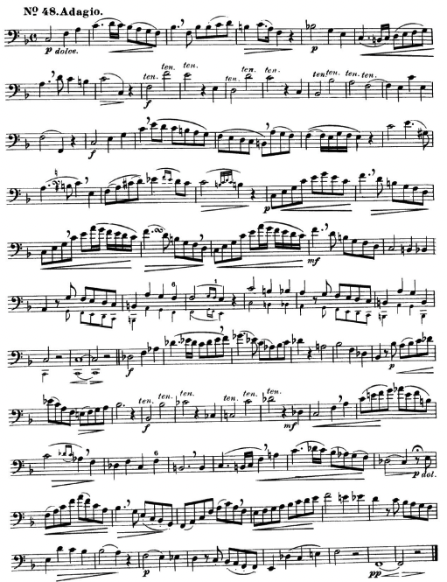

Tuba - Kopprasch, 60 Selected Studies (No. 47)

