Fall 2026
Large Instrumental Ensemble Auditions

FLUTE
Tuesday, August 25, 2026
6:00-7:30 p.m. Westbrook Music Building Room 205

Arrive before 6:00 p.m. and be prepared to play (instrument together and warmed up). You will choose an audition number upon arrival. Please do not gather outside the studio door during the auditions as the door is not soundproof.
Please indicate your ensemble preference on your audition form.

Please fill out the form below and bring to your audition
PLEASE WRITE LEGIBLY
UNL Large Instrumental Ensemble Audition Form

Name: _______________________________________________________________________
Phone: _______________________________ Email: ________________________________
State any known class conflicts with Symphony Orchestra (MWF 1:30-2:50) or Wind Ensemble (MWF 3:30-4:50) and your ensemble preference:
______________________________________________________________________________
______________________________________________________________________________
Do you have experience playing piccolo? Y / N
You may be considered to play piccolo in one of the ensembles even if you do not choose to audition on it.

*Those auditioning on piccolo: play excerpts nos. 1-4 on flute. Sight reading will be on piccolo.

1) Rimsky-Korsakov, Scheherazade, Mvt. III (four before M to N)

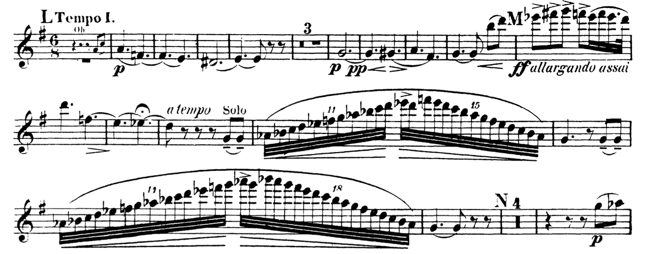

2) Rimsky-Korsakov, Scheherezade, Mvt. IV (B to C)

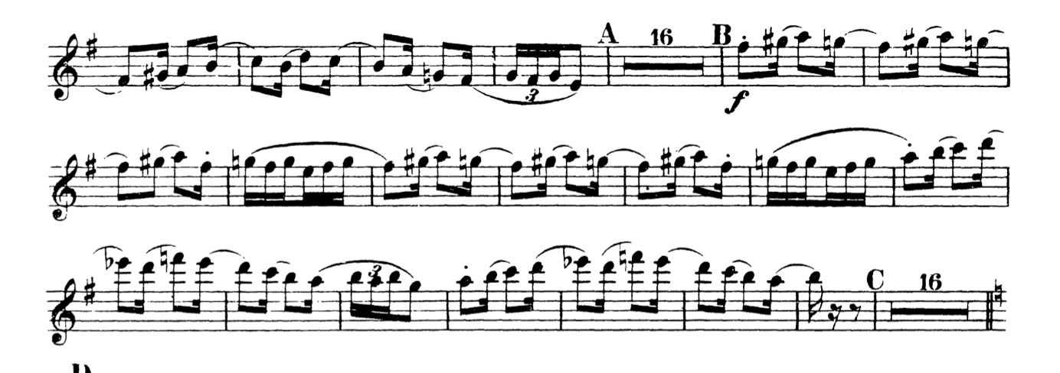
3) Brahms, Symphony No. 3, Mvt. III (pick-up to B to C)

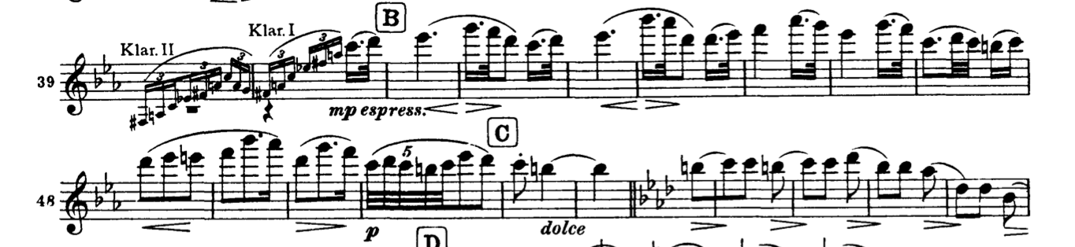

4) Beethoven, Symphony No. 3, Finale (five before B to thirteen before C)

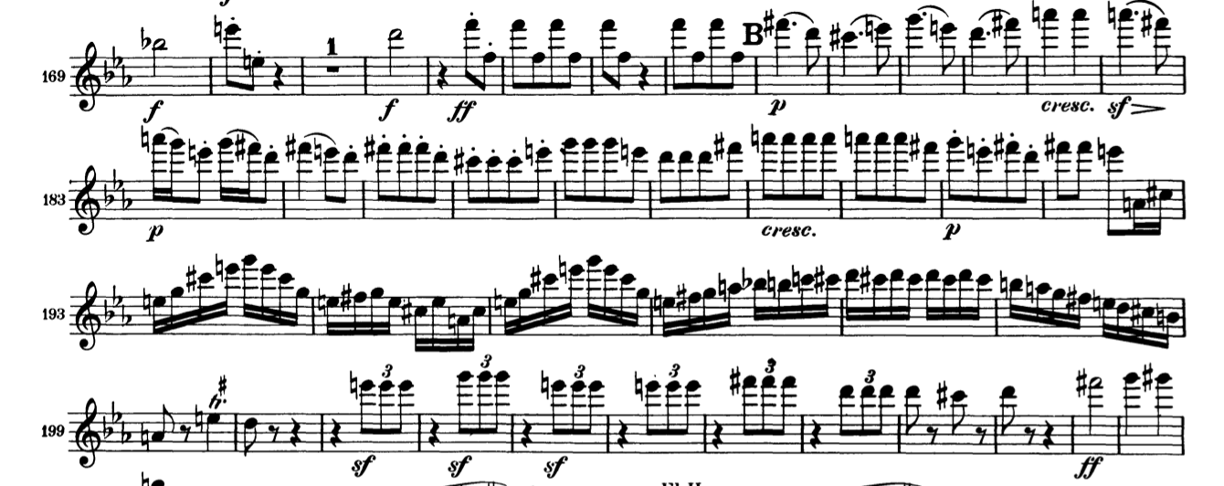

Sight reading material will be provided in the audition room.

