Fall 2026
Large Instrumental Ensemble Auditions

HORN
Monday, August 24, 2026
4:00-5:00 p.m. Westbrook Music Building Room 232

Arrive before 4:00 p.m. and be prepared to play (instrument together and warmed up). Please do not gather outside the studio door during the auditions as the door is not soundproof.
Please indicate your ensemble preference on your audition form.

Please fill out the form below and bring to your audition
PLEASE WRITE LEGIBLY
UNL Large Instrumental Ensemble Audition Form

Name: _______________________________________________________________________
Phone: _______________________________ Email: ________________________________
State any known class conflicts with Symphony Orchestra (MWF 1:30-2:50) or Wind Ensemble (MWF 3:30-4:50) and your ensemble preference:
______________________________________________________________________________
______________________________________________________________________________
Note: ensemble preference does not guarantee placement.
Ensemble placement results will be emailed within 24 hours.
1) Mozart – Rondo from Horn Quintet, K. 407 (beginning to the measure before C)

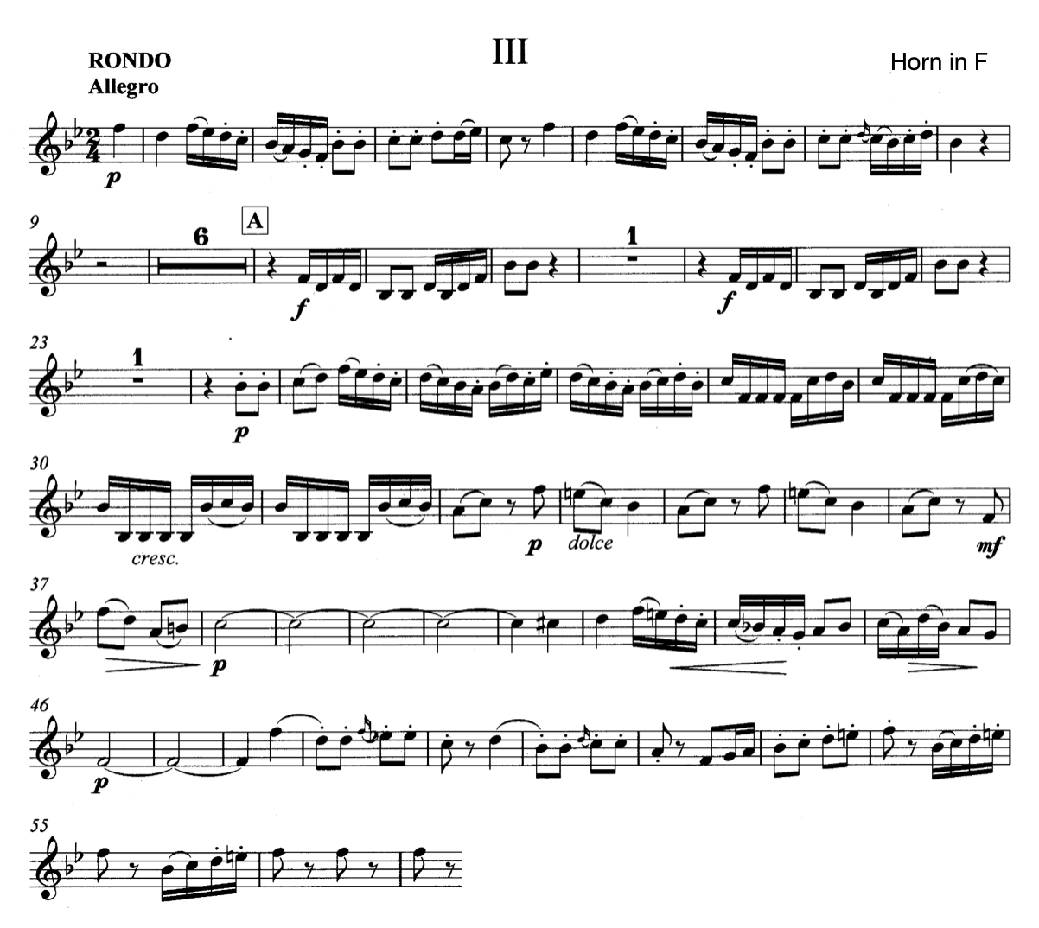

2) Hindemith – March from Symphonic Metamorphosis (5 after I to L)
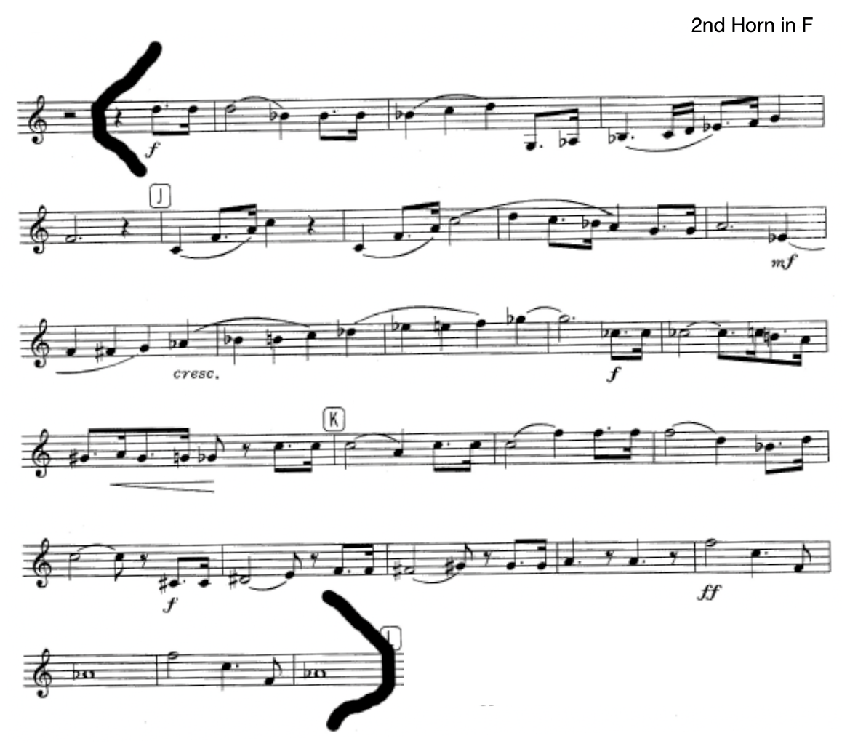

3) Grainger – Lincolnshire Posy, mvt. 1 (mm. 1-50)
