Fall 2026
Large Instrumental Ensemble Auditions

PERCUSSION
Monday, August 24, 2026
3:30-5:30 p.m. Westbrook Music Building Room 110

The audition is blind. Please make sure you come with all necessary equipment (music, sticks/mallets, small instruments, etc.) before entering the room.
Please arrive by 3:20 to receive your audition number/time from a GTA.
*Non-music majors and music minors play only the TIMPANI etude
**Music majors must play ALL of the material

Please indicate your ensemble preference on your audition form.

Please fill out the form below and bring to your audition
PLEASE WRITE LEGIBLY
UNL Large Instrumental Ensemble Audition Form

Name: _______________________________________________________________________
Phone: _______________________________ Email: ________________________________
State any known class conflicts with Symphony Orchestra (MWF 1:30-2:50) or Wind Ensemble (MWF 3:30-4:50) and your ensemble preference:
______________________________________________________________________________
______________________________________________________________________________

1) TIMPANI: Peters – Etude No. 61 from Fundamental Method for Timpani (all)
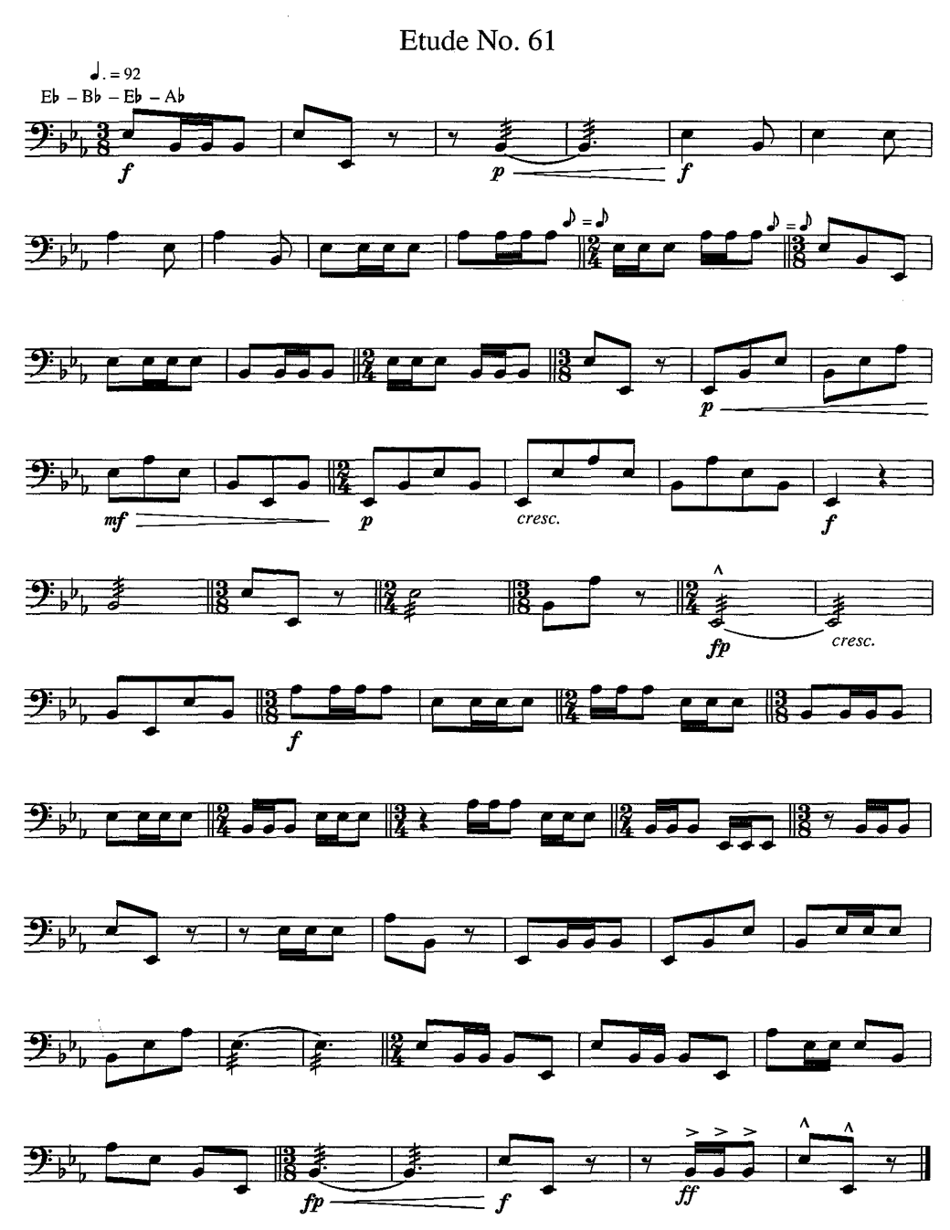

2) SNARE: Nielsen – Concerto for Clarinet and Orchestra (Reh. 28 to cadenza)
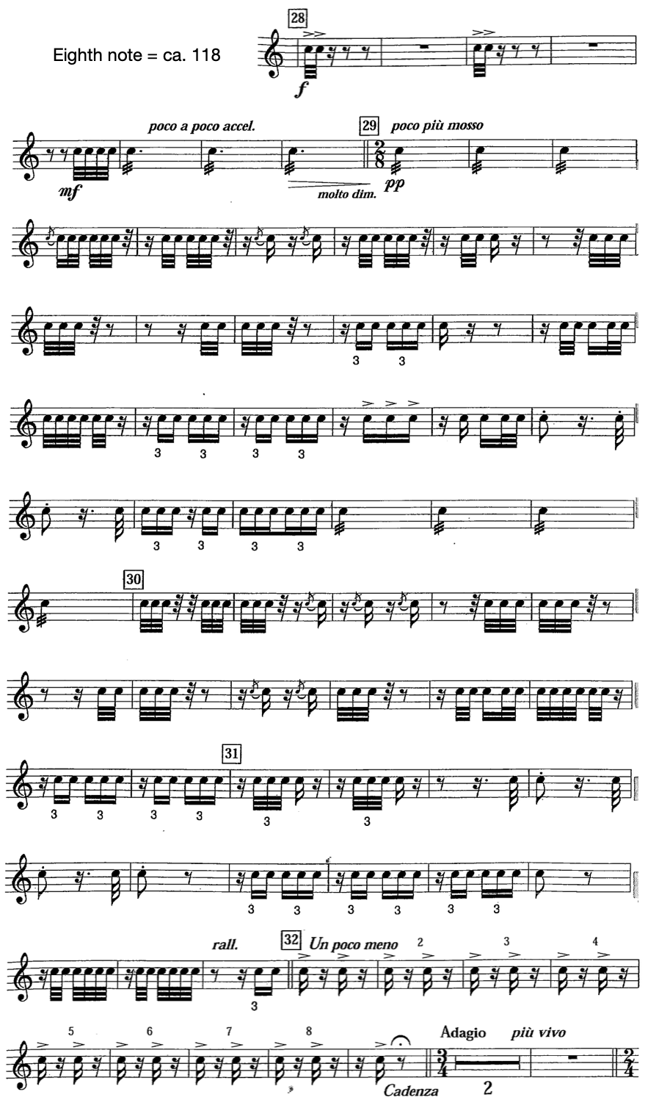
3) GLOCK: Tchaikovsky – The Sleeping Beauty, Mvt. 6 (pickups to Reh. 7 to Reh. 9)

